PatchIO – Smart Patches & Instruments Search App for Composers
Version 1.1.5 – July 13, 2025
Created by Shaked Shachar
PatchIO is a sleek, composer-first tool designed to help you instantly find the right sound or instrument across all your sample libraries — no matter the format, plugin, or file structure. Whether you're digging through Kontakt patches, WAVs, SINE libraries, or Engine folders, PatchIO helps you cut through the clutter and get to what feels right.
It's your musical assistant — built for speed, creativity, and intuition.
- Supported software instruments/patches for search:
Kontakt, SINE Player, Engine (by Best Service), Omnisphere, Spitfire, Logic, Audio files (any Splice or other downloaded sounds)

Who It’s For
PatchIO is made for composers, producers, and sound designers who work with large sample libraries and want a faster, smarter way to find patches that match a brief, mood, or genre.
Created by composer Shaked Shachar, this tool was designed to solve real workflow frustrations in professional scoring environments.

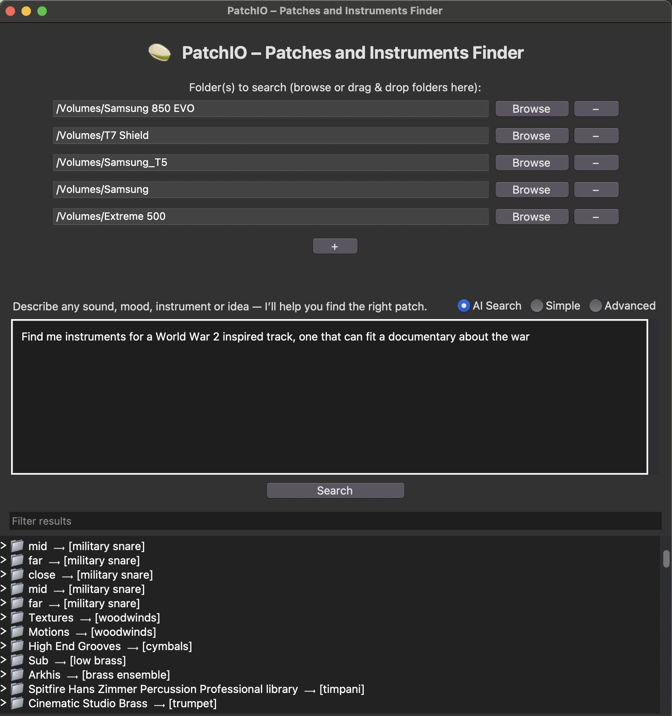
User Interface – Example for Usage

Features Overview
AI Search (natural language)
Just type a musical brief — like “quirky comedy cue” or “epic Viking battle” — and PatchIO uses AI to:
- Understand your intent
- Suggest smart keywords
- Automatically populate the Advanced tab with OR / AND / NOT filters
You can still tweak the results after they appear in the Advanced tab.

Simple Mode
Ideal for quick searches. Just enter a few basic keywords like:
celesta quirky
PatchIO will scan your folders and match any filenames or folders that include those terms.
💡 Use quotes around multi-word phrases to match them exactly:
pizzicato "soft piano" quirky
"bamboo flute" kalimba

Advanced Mode
For power users. Use structured filters to narrow down your results with precision:
- or: – At least one of these keywords should appear
- and: – All of these keywords must appear
- not: – Exclude any result with these keywords

Keyword Highlights in Results
When you perform a search in AI Mode, PatchIO analyzes your prompt and generates smart search keywords based on genre, mood, instrumentation, and cultural context.
In the results list, you’ll notice small arrow tags (➤) next to some folders. These indicate which keywords were matched inside that folder or its subfolders.
Example:
📁 Epic Battle Drums ➤ "tribal percussion" "war horns"
📁 Nordic Strings ➤ "tagelharpa" "ancient pluck"
This helps you understand why each result appeared, so you can quickly judge if it's worth exploring — without expanding every folder.
If you’re using Simple or Advanced mode, these hints reflect direct filename matches based on your input terms.
Filtering Results
PatchIO now includes a powerful Filter Results box that lets you instantly narrow down your search results by typing keywords to filter inside your current results list.
Kontakt Integration with Cubase (macOS only) — NEW (v1.1.5)
You can now automatically create and load Kontakt instruments directly in Cubase from any .nki, .nkm, or .nksn file found through PatchIO. (See steps to complete below)
Requirements:
- - macOS
- - Cubase 12 or later
- - Kontakt 8 (Modern View enabled) — not compatible with Classic layout
- - PatchIO v1.1.5 or later, with accessibility permissions enabled (under Privacy & Security)
- - A Cubase key command assigned to the “Add Instrument Track” action (you can find the command by searching for ‘instrument’ in Cubase Key Commands search window)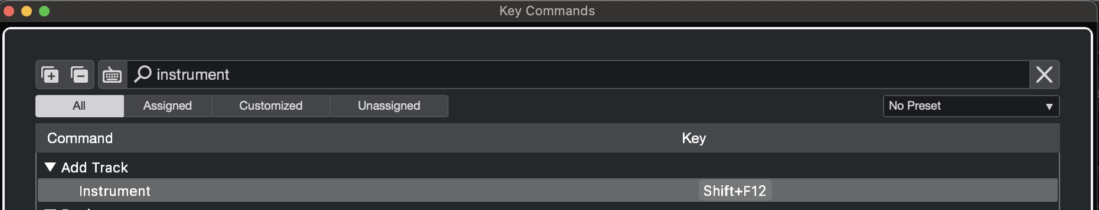
Default in PatchIO is `Shift+F12`, but you can change this in Preferences.

How it works:
- - Right-click a Kontakt-compatible patch in your search results.
- - Choose one of the options:
- - Create a new Kontakt instrument track in DAW — adds a new track and loads the patch.
- - Replace Kontakt instrument in DAW — swaps the current Kontakt patch (only works if Kontakt is visible).
- - PatchIO automates everything:
- - Brings Cubase to the front
- - Sends the configured key command (e.g. Shift+F12) to open the “Add Instrument Track” dialog
- - Selects Kontakt 8, sets the track name
- - Loads the patch using the Kontakt File > Load menu

💡 On first use, PatchIO will show a message explaining how to set up your Cubase key command.
You can change the default shortcut anytime in Preferences > Key Commands (under Settings menu).
This feature uses GUI scripting and is only supported on macOS. Make sure:
- - Cubase is running with a project open
- - You’ve assigned a key command to “Add Instrument Track”
- - The Kontakt 8 window’s default view is the modern view

File Extensions
PatchIO supports many formats: .nki, .wav, .patch, .aif, .preset, and more.
You can enable or disable specific file types in the Extensions section under preferences to narrow your search to:
- Only WAVs
- Only Kontakt instruments
- Or anything else!

Excluded Folders
You can exclude certain folders from the scan (like “Backups” or “Old Projects”) to avoid clutter.
Go to the Excluded Folders section under preferences and add any path you want PatchIO to skip.

Other Notes
- Works offline in Simple and Advanced mode
- AI Search requires an internet connection
- Works on Windows and macOS

